2019 Christmas Tree Lighting
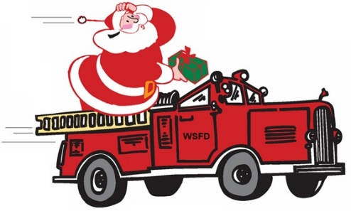
Friday, December 6th
^{6:00-9:00PM}
Ridge Volunteer Fire Department
13820 Point Lookout Road Ridge, MD 20680

- Please join us for a fun filled evening, and get you picture taken with Santa. There will be a tractor display, games, crafts, face painting and other fun activities for all ages.

- Point Lookout State Park will be attending and helping make bird feeders for all.

- Spring Ridge Middle School Rhythm Club will be performing from 6:00-6:30, and Great Mills High School chorus will be in attendance, they will welcome Santa as he arrives.

Santa will arrive between 6:30-6:45! *Please bring NON-EXPIRED and NON-PERISHABLE food item and/or toiletry item to donate to our local food pantry. You will receive an extra ticket for door prizes**

Pictures will not be provided this year, please bring your own camera/phone to take a picture with Santa!!! Cookies and Punch will be provided for all. **Hot dogs and chips will be available for $1.50**

